**DAILY ONLINE ACTIVITIES SUMMARY**

|  |  |  |  |  |  |  |  |  |
| --- | --- | --- | --- | --- | --- | --- | --- | --- |
| **Date:** | **17/06/2020** | | | | | **Name:** | **Shraddha Acharya** | |
| **Sem & Sec** | **4 Sem B sec** | | | | | **USN:** | **4al18cs079** | |
| **Online Test Summary** | | | | | | | | |
| **Subject** | | **-** | | | | | | |
| **Max. Marks** | | **30** | | **Score** | | | **-** | |
| **Certification Course Summary** | | | | | | | | |
| **Course** | **1)Introduction to full stack development** | | | | | | | |
| **Certificate Provider** | | | **Great learning Academy** | | **Duration** | | | **8 hours** |
| **Coding Challenges** | | | | | | | | |
| **Problem Statement:1) Write a python program to check whether the given binary tree is a valid binary tree.**  **2) Write a C program to count numbers that don’t count 3.** | | | | | | | | |
| **Status:Done** | | | | | | | | |
| **Uploaded the report in Github** | | | | | **Yes** | | | |
| **If yes Repository name** | | | | | **1)**[**https://www.github.com/shraddhaacharya/Lockdown-JavaCodding/tree/master/BST.PY**](https://www.github.com/shraddhaacharya/Lockdown-JavaCodding/tree/master/BST.PY)  **2)** **https://www.github.com/shraddhaacharya/lockdown-C-coding/tree/master/Countnumber.c** | | | |
| **Uploaded the report in slack** | | | | | **Yes** | | | |

Certification Course Details: Today in the course of Introduction to Full stack development I learnt about Introduction to forms.

Snapshot

1. Introduction to Full stack development

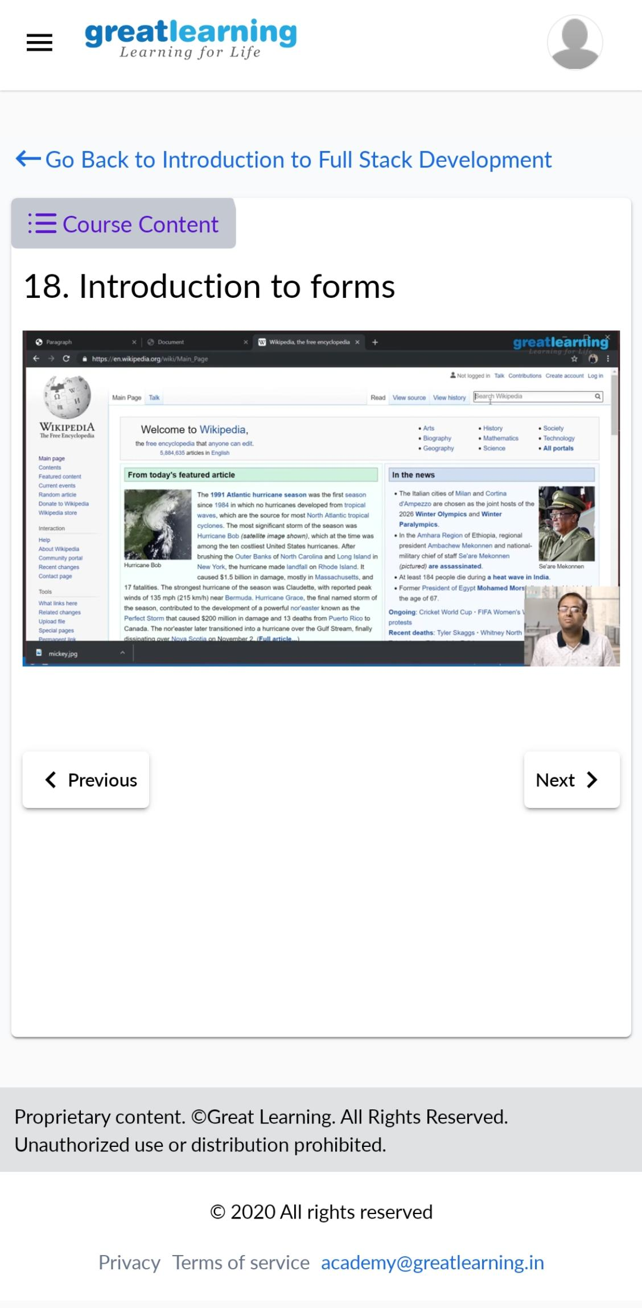

Coding Challenges Details:

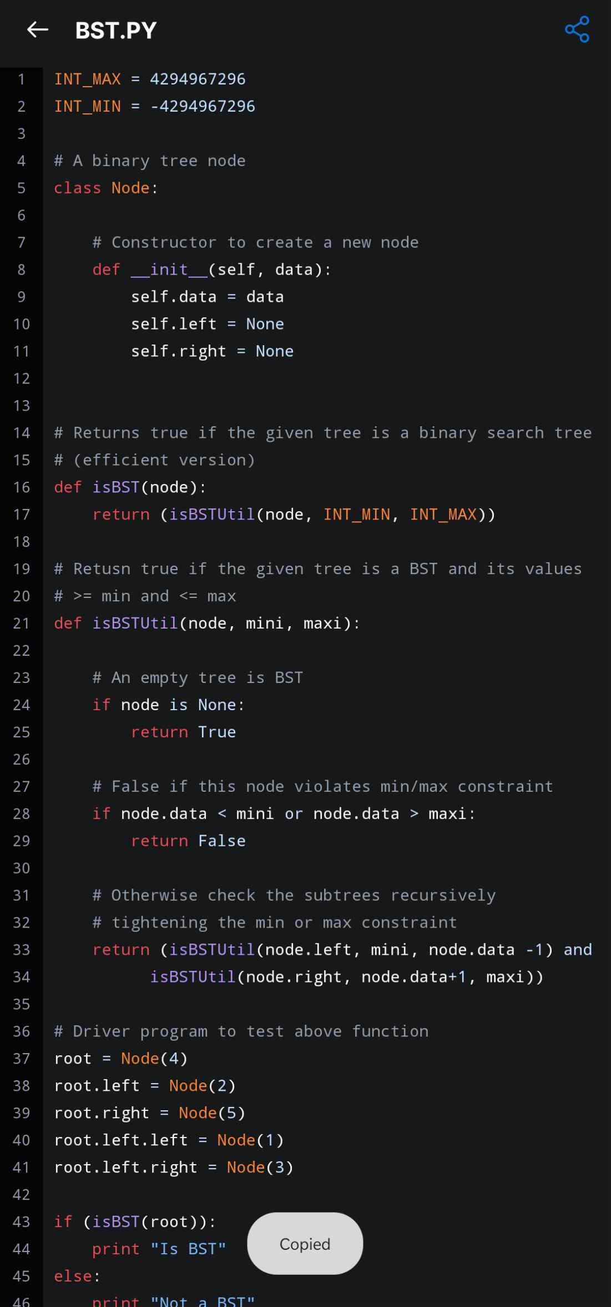1)Write a python program to check whether the given binary tree is a valid binary tree.

2) Write a C program to count numbers that don’t count 3.

